

# Lab Assignment 1

Fall 2024

**Course Title: Structured Programming Lab**

**Course Code: CSE 1202 (Fall 2024)**

# Submitted by: Student Name and ID

Md. Tazminur Rahman Tanim (242014124)

# Department of CSE

**University of Liberal Arts Bangladesh (ULAB)**

1. Write a C program to enter the radius of a circle and find its circumference and area. Note that‬Circumference = 2 x π x radius, Area = π x (radius)‬

**Answer:**

|  |
| --- |
| **Code** |
| #include <stdio.h>  int main() {  float radius, circumference, area;  const float pi = 3.1416;  printf("Enter radius of the circle: ");  scanf("%f", &radius);  circumference = 2 * pi * radius;  area = pi * radius * radius;  printf("Circumference: %.2f\n", circumference);  printf("Area: %.2f\n", area);  return 0;  } |

**Algorithm:**

Steps to follow for the solution:‬

1. Input the radius of the circle.

2.Calculate circumference using the formula Circumference=2×π×radius

3.Calculate area using the formula Area=

4. Display the circumference and area

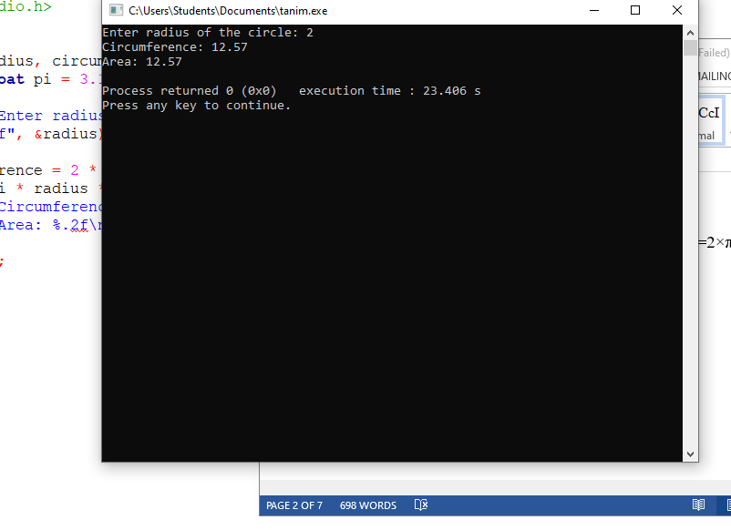

2. Write a C program to calculate and display the total salary of an employee considering that‬ total salary is the sum of basic salary and house rent. The program must ask the user for the basic‬ salary and percentage of basic salary which determines the house rent.‬

**Answer:**

|  |
| --- |
| **Code** |
| #include <stdio.h>  int main() {  float basic_salary, percentage, house_rent, total_salary;  printf("Enter basic salary and house rent percentage: ");  scanf("%f %f", &basic_salary, &percentage);  house_rent = basic_salary * (percentage / 100);  total_salary = basic_salary + house_rent;  printf("Total Salary: %.2f\n", total_salary);  return 0;  } |

Steps to follow for the solution:‬

a. Input the basic salary and percentage of basic salary for house rent.

b. Calculate house rent using the formula House Rent

$=Basic Salary×\frac{percentage}{100}$

c. Calculate total salary by adding basic salary and house rent.

d. Display the total salary.

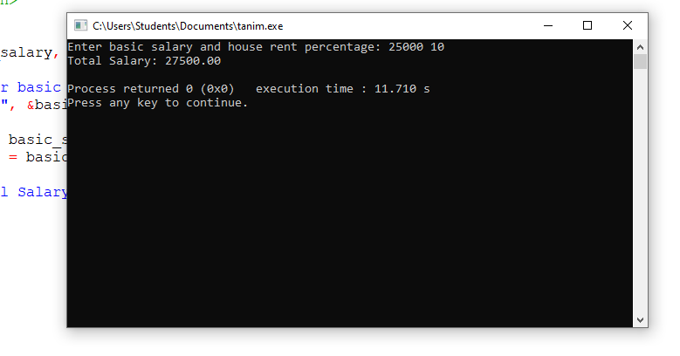

3. Write a C program that takes number of days as input, and then converts it into years and days,‬ and displays the results. Assume that, 1 year = 365 days.‬‬

**Answer:**

|  |
| --- |
| **Code** |
| #include <stdio.h>  int main() {  int days, years, remaining_days;  printf("Enter number of days: ");  scanf("%d", &days);  years = days / 365;  remaining_days = days % 365;  printf("Output: %d years %d days\n", years, remaining_days);  return 0;  } |

Steps to follow for the solution:‬

a. Input the number of days.

b. Calculate years by dividing days by 365.

c. Calculate remaining days by using modulus operation.

d. Display years and remaining days.

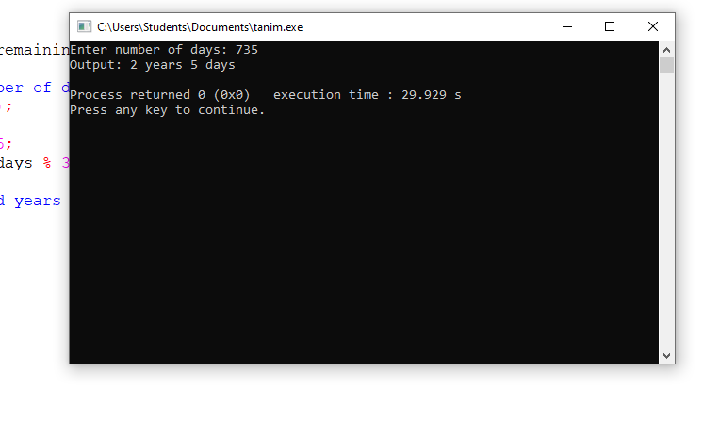

4. Take two inputs from user and find out sum, subtract multiplication and division.‬‬

**Answer:**

|  |
| --- |
| **Code** |
| #include <stdio.h>  int main() {  int a, b;  printf("Enter two numbers: ");  scanf("%d %d", &a, &b);  printf("Sum: %d\n", a + b);  printf("Subtract: %d\n", a - b);  printf("Multiplication: %d\n", a * b);  if (b != 0)  printf("Division: %d\n", a / b);  else  printf("Division: not possible to divide by 0\n");  return 0;  } |

Steps to follow for the solution:‬

a. Input two numbers.

b.Calculate the sum, difference, product, and quotient of the two numbers.

c. If the second number is zero, display a message that division is not possible.

d. Display the results.

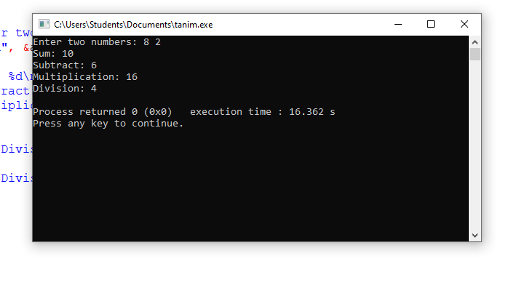

5. Find out average of four numbers

**Answer:**

|  |
| --- |
| **Code** |
| #include <stdio.h>  int main() {  float a, b, c, d, average;  printf("Enter four numbers: ");  scanf("%f %f %f %f", &a, &b, &c, &d);  average = (a + b + c + d) / 4;  printf("Average: %.2f\n", average);  return 0;  } |

**Algorithm:**

Steps to follow for the solution:

a. Input four numbers.

b. Calculate the sum of the four numbers.

c. Divide the sum by 4 to get the average.

d. Display the average.

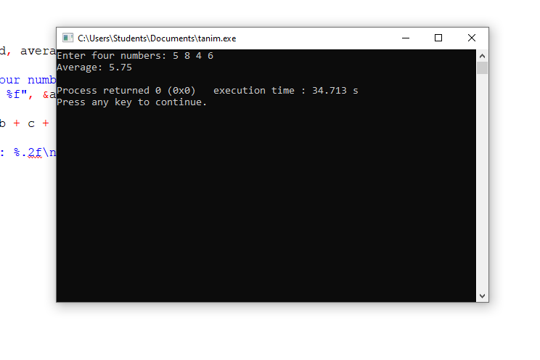

6. Convert Celsius temperature to Fahrenheit Algorithm:

**Answer:**

|  |
| --- |
| **Code** |
| #include <stdio.h>  int main() {  float celsius, fahrenheit;  printf("Enter temperature in Celsius: ");  scanf("%f", &celsius);  fahrenheit = (celsius * 9 / 5) + 32;  printf("Temperature in Fahrenheit: %.2f\n", fahrenheit);  return 0;  } |

**Algorithm:**

Steps to follow for the solution:

a. Input temperature in Celsius.

b. Convert to Fahrenheit using the formula $F=C×\frac{9}{5}+32$

c. Display the temperature in Fahrenheit.

